Current Operable Unit 3 Remedial Progress for Phase II Week Ending 5/21/10
Creamer Environmental Inc., National Grid’s Remediation Contractor, is continuing to install the internal bracing system (Walers) to the sheet pile line and will continue to do so for the next few weeks.
GEI, National Grid’s Remediation Oversight Consultant, will continue to perform CAMP (Community Air Monitoring Program) and Noise and Vibration monitoring. CAMP and Noise and Vibration monitoring will continue throughout the project.

Two-Week Outlook
Creamer Environmental Inc. will continue to install the Waler system in each of the four cells for the next few weeks. Once each cell is completed with the Waler support system, Creamer will then excavate to design depth followed by backfilling of the excavation. It is anticipated to start excavation, backfilling and T&D of cell 11the week beginning 5/24/10.
General hours of operation will continue to be Monday through Friday, 7:00 AM to 3:30 PM. However, work hours will be extended when necessary to maintain schedule or to complete critical tasks. Monday May 31st 2010 there will be no site activities due to the holiday. Work will resume as normal on Tuesday June 1st 2010.
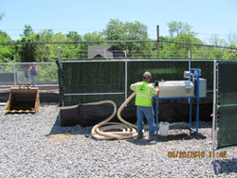
Installing Piian odor neutralizer system along fence line.
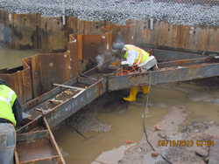
Workers welding in support beams

